FOCP C Programming Assignment
Module 2: Conditional Statements and Operators
Question 1: Conditional Statements in C
Platform: HackerRank
Programming Language: C
Problem Statement URL:
https://www.hackerrank.com/challenges/conditional-statements-in-c/problem
Problem Statement
Given a positive integer n, do the following:
- If n is between 1 and 9, print the lowercase English word corresponding to the number (for example, one for 1, two for 2, etc.).
- If n is greater than 9, print Greater than 9.
Input Format:
The first line contains a single integer n.
Constraints:
1 <= n <= 100
Output Format:
Print the lowercase English word corresponding to n if n is between 1 and 9; otherwise, print Greater than 9.
Sample Input 1:
5
Sample Output 1:
five
Sample Input 2:
44
Sample Output 2:
Greater than 9
Source Code
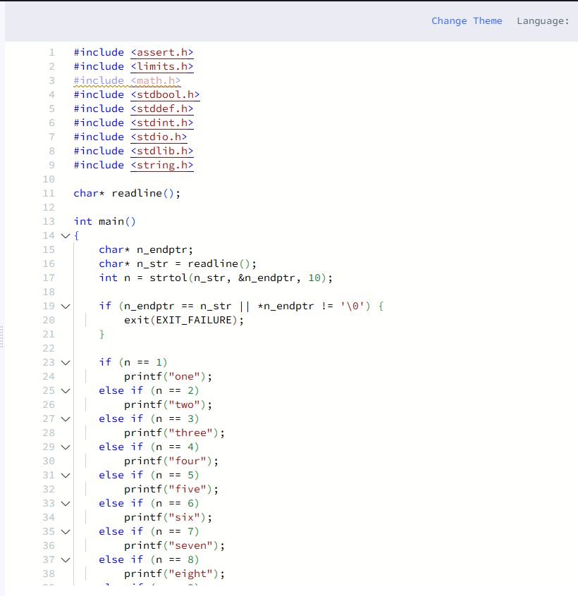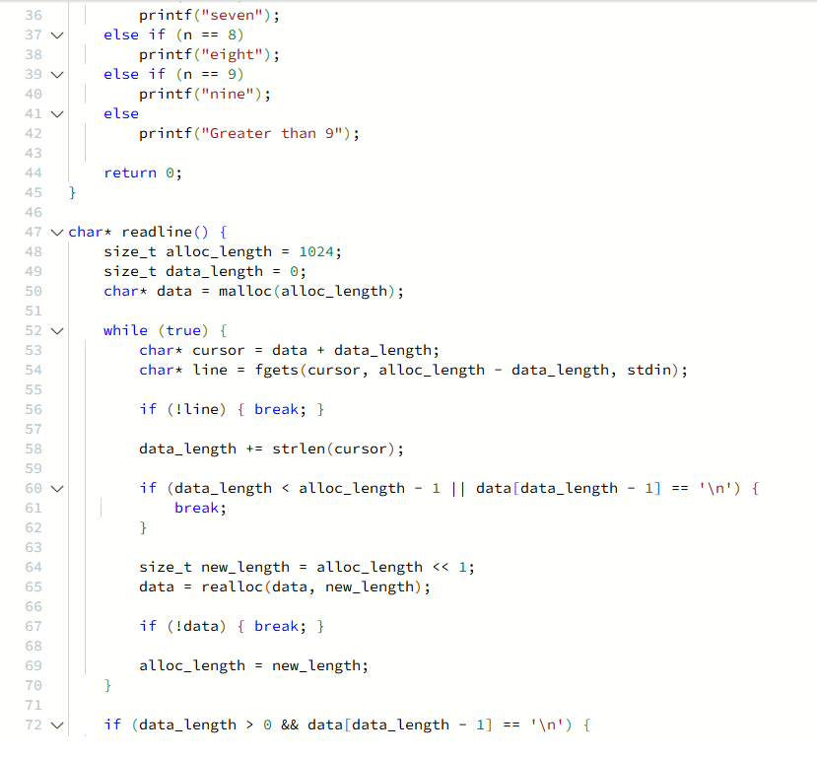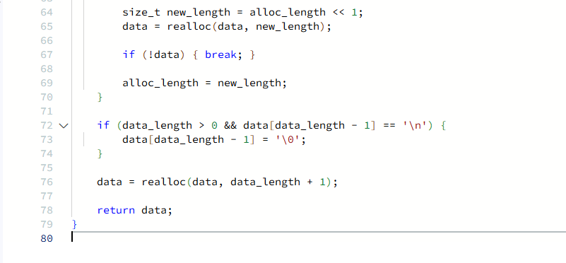

Output
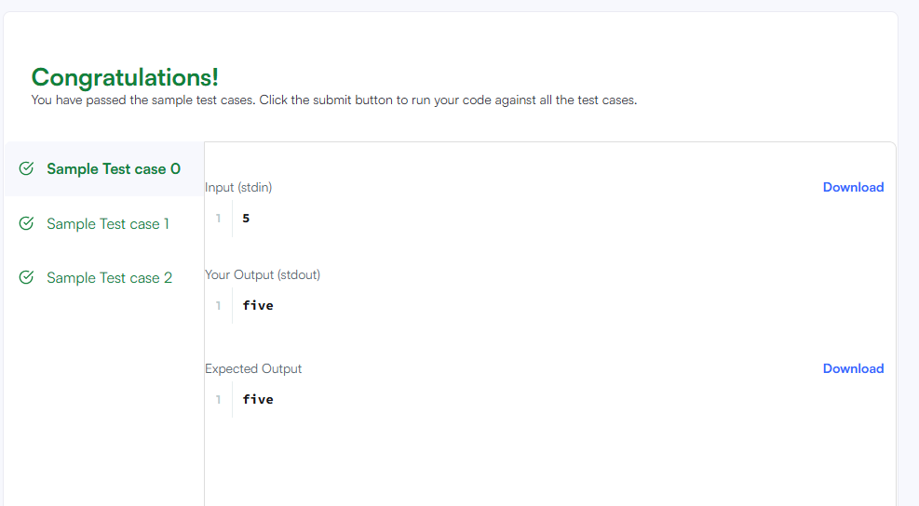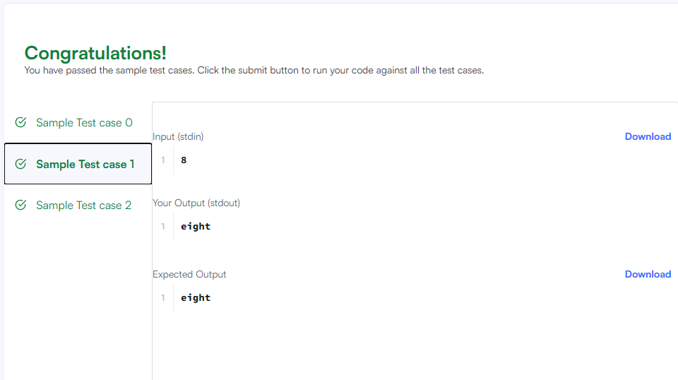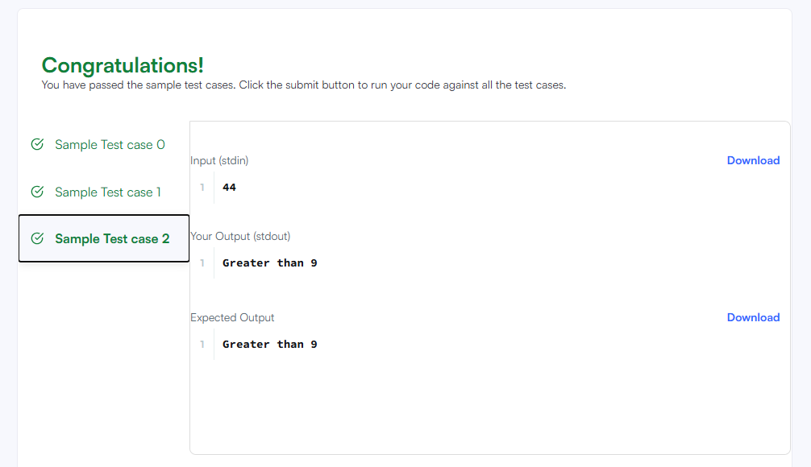Result
The program was executed successfully, and the submission was accepted on HackerRank.

